# **He kupu whakamahuki**

**Puwhāorangi**

**Te Pakeketanga 8+**

**Taumata 3 – 6**

Ko tēnei aratohu kaiako ka tiki atu i ētehi o ngā kōrero tuku iho mō Pūwhaorangi ka tōia mai ki konei hei kaupapa ako mā ngā ākonga. Ko tēnei aratohu kaiako ka hāngai hoki ki te pukapuka matihiko mō Pūwhaorangi.

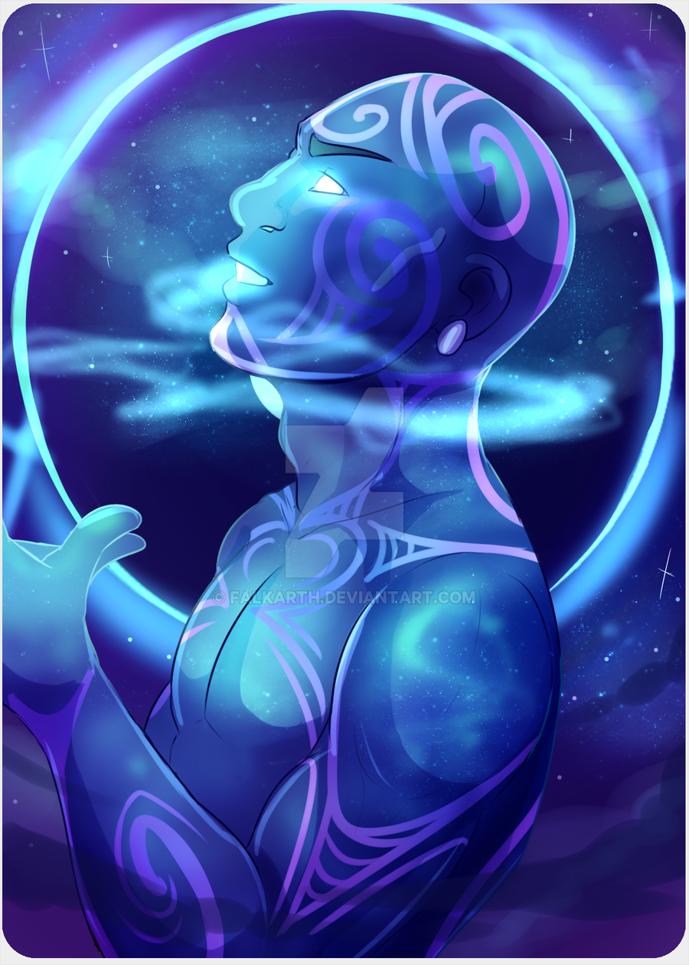Ko te kauwaka ki te tūhura i ēnei kōrero ko ēnei kei raro iho nei. Ko ēnei kaupapa ka noho hei wāhanga matua mō tēnei rauemi.

* **Te ara ki te aotūroa**
* **Pūwhaorangi**
* **Te hekenga a rangi**

**Akoranga tōmua**

I mua i te ruku ki ngā kaupapa o tēnei aratohu kaiako ka taea e te kaiako me ngā ākonga ēnei kaupapa te tirotiro.

* Te Arawa Waka
* Pūwhaorangi
* Pūhaorangi
* Pareārau
* Rangawhenua
* Runukuiroiroapou (Matawhero)
* Tamatekapua
* Ohomairangi
* Houmaitawhiti me Uenuku
* Te hekenga a rangi
* Te Kuraimonoa
* Ruamuturangi
* Taungatapu
* Mawaketapu
* Uruika
* Rangitapu
* Kahumatamomoe
* Ngā pūmanawa e waru o Te Arawa



**Ngā kai o roto**

**Ngā Kaupapa** **Whārangi**

Ngā wāhanga o Te Marautanga o Aotearoa 3

Wāhanga 1 4

Te ara ki te aotūroa

Wāhanga 2 6

Pūwhaorangi

Wāhanga 3 8

Te hekenga a rangi

Ngā rauemi tautoko 10

# 

# 

# **Ngā kaupapa matua**

Ko ēnei ngā kaupapa matua o tēnei puka aratohu kaiako, katoa ēnei kaupapa e hāngai ana ki te kaupapa “Pūwhaorangi”.

**Wāhanga 1** Te ara ki te aotūroa

**Wāhanga 2** Pūwhaorangi

**Wāhanga 3**  Te hekenga a rangi

# **Te Hononga ki TMoA**

Anei ngā wāhanga o TMoA me ngā whenu o ia wāhanga e hāngai ana ki

ngā kaupapa matua o tēnei aratohu kaiako. Ko ngā ngohe me ngā papa mahi

o ia wāhanga ka hāngai ki ēnei kei raro iho nei.

**Te Pakeketanga 8+**

**Taumata 3–6**

|  |  |  |
| --- | --- | --- |
| **TMoA** | **Whenu** | |
| Tikanga ā-iwi | Te Ao Hurihuri | Te Wāhi me te  Taiao |
| Putaiao | Te Ao Tūroa | Ō Kawekawe |
| Te Reo | Ā-Tā | Ā-Waha |

**Wāhanga 1** – **Te ara ki te aotūroa**

He atua a Pūwhaorangi, he poutiriao nō ngā rangitūhāhā, nō Rangipātohu. He nui ngā kōrero mō Pūwhaorangi mai i tana taenga mai ki te aotūroa nei engari he ruarua ngā kōrero mō te atua nei i mua i tōna taenga mai ki konei. Ko ngā kōrero o tēnei wāhanga e hāngai ana ki te ara i whāia e Pūwhaorangi kia tae pai mai ki te konei ki te aotūroa. Ki konei kitea hoki ai ko Pūwhaorangi kē te kaipōkai tuarangi tuatahi o te ao.

|  |  |  |  |
| --- | --- | --- | --- |
| Te wāhanga o TMoA | Te Whenu  Te Whāinga Paetae | Ngā kawenga mā te kaiako | Ngā mahi a te ākonga |
| **Tikanga ā-Iwi** | **Te Wāhi me te Taiao**  **5.1**  Ka whakamārama i ngā take e neke haere ai te tangata ki wāhi kē, me ngā putanga iho o ēnei nekehanga ki te tangata me te wāhi | **Pareārau**  Ko te ara i whāia e Pūwhaorangi ko te ara o ngā aorangi. Ko te aorangi tuatahi i tohu i tōna ara ki te ao tūroa ko te aorangi o Pareārau. Mā te kaiako ēnei kōrero e whāngai ki ngā tamariki ka tuku i a rātou ki te rangahau i ētehi kōrero mō Pareārau, me kimi e rātōu ngā meka 10 e whakamārama ana i ngā āhuatanga o Pareārau. | **Pānui whakaahua**  **He mahi takirua**  Ko tā ngā ākonga mahi he whakarite i tētehi pānui whakaahua e whakatairanga ana e pānui ana i ngā meka 10 kua rangahaua e rātou hei whakapoapoa i te tangata ki te tāpoi i te aorangi o Pareārau.  Mā te ākonga te pānui whakaahua e whakamahere  Mā te ākonga hoki e whakatau mehemea ka hanga ā-pepa mehemea rānei ka hangaia ā-rorohikotia. |
| **Putaiao** | **Ō Kawekawe**  **Te Hanga Matū**  **3**  Ka ako haere i te āhua korakora o te matū hei whakamārama i ngā panoni matū e kitea ana. | **Rangawhenua (Jupiter)**  Ko te aorangi tuarua i hipa a Pūwhaorangi ko Rangawhenua. Tukuna ngā ākonga ki te rangahau i te aorangi nei me te whakautu i ēnei pātai.   * E hia te tawhiti o Rangawhenua i te rā? * I hangaia a Rangawhenua ki te aha? * He aha te huarere o Rangawhenua? * He aha ngā tae o Rangawhenua? * E whia ngā marama o Rangawhenua? * E hia te roa o te rere atu ki te aorangi o Rangawhenua. | **Bath Bombs**  **He mahi takitahi**  Ko tā te ākonga he patopato i ngā pātai me ngā whakautu kua rangahaua e ia mō te aorangi o Rangawhenua. Ka mutu i a ia te pato i tāna i rangahau ai ka huri ki te hanga “bath bombs”  Mā te kaiako ngā rauemi me ngā taputapu mō ngā bath bombs e whakarite.  Mā te kaiako hoki tēnei mahi e āta whakamārama e āta whakaako ki ngā ākonga.  Anei tētehi paetukutuku hei āwhina i a koe ki te whakaako i te hanga bath bombs.  <https://diyprojectsforteens.com/diy-bath-bombs-recipe/>  Ko te whāinga kia rite te āhua o ngā bath bombs ki te āhua o te aorangi o Rangawhenua. |
| **Te Reo** | **Ā-Tā**  **Puna Reo**  **6.2**  Ka whānui te puna kupu e taea ai te tautoko, te whakawhitiwhiti māramatanga, te whakakotahi hei whakatau, hei whakaiti rānei. | **Runukuiroiroapou (Matawhero)**  Ko te aorangi whakamutunga i hipa a Pūwhaorangi ko Runukuiroiroapou, koinei te aorangi whakamutunga i tōna ara. Mā te kaiako ēnei kōrero e whāngai ki ngā tamariki ka tuku i ngā ākonga ki te rangahau i te kaupapa nei ki te kūkara mō te hāwhe hāora, mutu ana te hāwhe hāora ka noho tahi te akomanga ki te kaiako ki te ōhia manomano i ngā kōrero kua kitea e rātou.  Mutu ana ngā mahi rangahau mō te aorangi, tohutohutia ngā ākonga ki te rangahau i tētehi tohutaka ki te hanga i tētehi pihikete Mars bar. | **Mahi takirua**  Ko tā te ākonga mahi he āta tuhi i tētehi tohutaka mō te tunu pihikete Mars Bar. Ki te tohutaka me kite e te kaiako ēnei mea.   * Ngā taputapu * Ngā kai * Ngā tohutohu taka kai   Mā te kaiako ngā kai e tiki kia taea e ngā ākonga te pihikete te tunu.Anei tētehi pae tukutuku hei āwhina i ngā ākonga ki te hanga pihikete Mars.  <https://kidspot.co.nz/recipe/mars-bar-slice/> |

**Wāhanga 2 –** **Pūwhaorangi**

Ko tēnei wāhanga e hāngai pū ana ki te atua a Pūwhaorangi me ngā kaupapa huhua e hāngai ana ki a ia.

|  |  |  |  |
| --- | --- | --- | --- |
| Te wāhanga o TMoA | Te Whenu  Te Whāinga Paetae | Ngā kawenga mā te kaiako | Ngā mahi a te ākonga |
| **Tikanga ā-Iwi** | **Te Ao Hurihuri**  **5.1**  Ka whakamārama i te whakaawenga o ngā tūāhua o mua i ngā hononga i roto, i waenga hoki, i te rōpū, me te haere tonu o ēnei whakaawenga. | **Whakapapa**  Mā te kaiako e whāngai ngā kōrero whakapapa ki te akomanga kia mārama ki ngā ākonga ko wai ngā tamariki, ngā mokopuna a Pūwhaorangi. Ka tukuna hoki kia haere ngā tamariki ki te rangahau i ētehi kōrero e pā ana ki te whakapapa o Pūwhaorangi.  Anei tētehi paetukutuku hei tirotiro mā te kaiako e whakaatu ana i te whakapapa o Te Arawa.  <https://teara.govt.nz/en/whakapapa/1508/te-arawa-genealogy> | **He pā harakeke**  **He mahi takitahi**  Mai i ngā kōrero kua tukuna kua rangahaua e ngā ākonga mō Pūwhaorangi ko tā te ākonga mahi he tā he tuhi hoki i te whakapapa o Pūwhaorangi.  Mā te ākonga e whiriwhiri i te āhua e whakaaturia ai te whakapapa o Pūwhaorangi engari ko te whāinga kia 4 ngā reanga o raro iho i a Pūwhaorangi e whakaatuhia ana.  Kia kotahi hoki te rerenga kōrero mō ia tātai hekenga o Pūwhaorangi e whakamārama ana ko wai ia. |
| **Putaiao** | **Te Ao Tūroa**  **Papatuānuku**  **4(i)**    Ka mārama haere ki ngā āhuatanga nui o te mata o Papatūānuku, arā, te wai, te toka, te one, me ngā āhuatanga e taea ai te ora i reira. | **Te hekenga a rangi**    Ko te hekenga a rangi te ingoa i tukuna ki ngā uri katoa i heke mai i a Pūwhaorangi.  He atua a Pūwhaorangi nō ngā rangi tūhāhā i heke mai ki te ao tūroa nei ka moe i a Te Kuranuiomonoa ka puta i a rāua ko ngā uri o Te Arawa me Tūwharetoa.  Mā te kaiako te whānuitanga o ēnei kōrero e tuku ki ngā ākonga ka tahuri atu ki te ngohe. | **Mapi Rohenga**  **He mahi Takitahi**  Mai i ngā kōrero kua tukuna ki ngā ākonga mō te hekenga a rangi. Ko te mahi a te ākonga he tā i tētehi mapi rohenga ki te whakaatu i te rohe e noho ana ngā uri a Pūwhaorangi.  Ka tā te ākonga mahi he āta tautohu ki te mapi ngā rohe e noho ana ngā uri o Pūwhaorangi. |
| **Te Reo** | **Ā-Tā**  **Puna Reo**  **5.2**  Ka hāngai ngā kupu me te āhua tonu o te whakatakoto kupu ki te kaupapa | **Tuhinga whakamārama**  **He mahi Takitahi**  Mai i ngā kōrero kua tukuna ki ngā ākonga mō te hekenga a rangi, ko te mahi a te ākonga he tuhi i ētehi kōrero e tautoko ana i taua mapi rohenga.  Mā te ākonga e āta whakamārama ngā kōrero mō ngā iwi me ngā rohe e noho nei rātou, ka tāpirihia ki te mahi hei taunaki i ngā tautohutanga kei te mapi. |

**Wāhanga 3** – **Te hekenga a rangi**

E ai ki te kōrero ko ngā uri katoa i takea mai i a Pūwhaorangi kua kīia he hekenga a rangi, ko Pūwhaorangi i heke iho mai ki te aotūroa nō ngā rangitūhāhā nā konā kīia ai ōna uri te hekenga a rangi. Ko tēnei wāhanga e hāngai ana ki ētehi o ōna uri.

|  |  |  |  |
| --- | --- | --- | --- |
| Te wāhanga o TMoA | Te Whenu  Te Whāinga Paetae | Ngā kawenga mā te kaiako | Ngā mahi a te ākonga |
| **Tikanga ā-Iwi** | **Te Whakaritenga Pāpori me te Ahurea**  **4.2**  Ka whakamārama i ngā take me ngā huarahi e tukuna iho ai e te takitahi me ngā rōpū, ō rātou ahurea, ō rātou tuku ihotanga, kia mau pūmau. | **Ohomairangi**  Ko Ohomairangi tētehi uri nā Pūwhaorangi rāua ko Tekuraimonoa. He nui tonu ngā mahi a Ohomairangi engari ko tētehi tino kaupapa e mōhiotia whānuitia ana ko tāna noho ki te tiaki i te marae o Taputapuātea ki Rangiātea i Hawaiki.  Mā te kaiako tēnei kaupapa me ētehi atu kōrero mō Ohomairangi e whāngai ki ngā ākonga.  Anei tētehi paetukutuku hei tirotiro mā te kaiako me ētehi kōrero mō Ohomairangi  <https://teara.govt.nz/en/te-arawa/page-1> | **Kōrero whakamārama - Profile** (Canva)  **He mahi Takitahi**  Mai i ngā kōrero kua whāngaihia ki te ākonga mō Ohomairangi ko tā te ākonga mahi he tuhi i tētehi kōrero whakamārama mō Ohomairangi e whakamārama ana i ēnei āhuatanga kei raro iho nei.   * Tōna wāhi noho * Tōna mahi * Tōna whakapapa * Ngā mahi pai ki a ia * Ngā mahi kua mahia e ia.   Me whakamahi e te ākonga te taupānga canva ki te tuhi me te hanga i tēnei kōrero whakamārama. |
| **Putaiao** | **Te Ao Tūroa**  **Te Taiao**  **4.3**  Ka āhukahuka, ka whakamārama i ngā panoni o ngā momo koiora (me ngā mea motuhake o Aotearoa), o neherā tae noa ki tēnei wā | **Houmaitawhiti me Uenuku**  Mā te kaiako ngā kōrero mō Houmaitawhiti me Uenuku e whāngai ki ngā ākonga. Ko ēnei kōrero e hāngai ana ki te kainga o Uenuku i te kurī o Houmaitawhiti me te kimi utu o Tamatekapua me Whakatūria mo ngā mahi a Uenuku.  Mā te kaiako te whānuitanga o ēnei kōrero e whangai ki ngā ākonga. Mutu ana te āta whāngai o te kaiako ka noho takirua ngā ākonga ki te āta ōhia manomano i ngā wāhanga matua o ngā kōrero nei.  Anei tētehi paetukutuku hei tirotiro mā te kaiako e whakarāpopoto ana i ngā kōrero mō Houmaitawhiti me Uenuku  <https://teara.govt.nz/en/photograph/1555/houmaitawhiti> | **He tuhi pukapuka (story bird)**  **He mahi takirua**  Mai i ngā kōrero kua whāngaihia ki ngā ākonga mō Haumaitawhiti me Uenuku ko tā ngā ākonga mahi he tuhi pukapuka mō te kura teina e āta whakamārama ana i ia āhuatanga i ia wāhanga o ēnei kōrero tuku iho. E tuhi ana ngā ākonga i tēnei pukapuka mō ngā pīpī o te kura nō reira kia pērā te taumata o te reo me ngā pikitia.  Ko te taupānga ka whakamahia mō tēnei pukapuka ko te story bird. |
| **Te Reo** | **Ā-Tā**  **Puna Reo**  **4.4**  4. Ka tika te tātaki kupu hou me te whai i ngā ture o te reo. | **Tamatekapua**  Nā te nui o ngā kōrero mō Tamatekapua, tukuna ngā tamariki ki te rangahau i te rangatira nei. He momo whakataetae, ko te rōpū tuatahi ki te kimi i ngā meka 10 e pā ana ki a Tamatekapua ka whiwhi i tētehi taonga (mā te kaiako e whakatau) | **He tuhinga auaha**  **He mahi takirua**  Mai i ngā kōrero kua rangahaua e ngā ākonga mō Tamatekapua ko ā rāua mahi he tuhi i tētehi tuhinga auaha e whakamārama ana i ētehi āhuatanga o Tamatekapua. Ko te huarahi e auaha ai ngā tuhinga ko ēnei kei raro iho nei.   * Waiata * Pao * Mōteatea * Ruri * Rotarota   Mā ngā ākonga te rangi me te momo waiata e whiriwhiri. |

# **Ngā rauemi tautoko**

**Pukapuka**

Best, Eldson. (1899). "Notes on Maori Mythology." Journal of the Polynesian Society 8:93-121, p. 108.

Tregear, Edward. (1891). Maori-Polynesian Comparative Dictionary. Wellington: Government Printer, p. 367.

White, John. (1887). Ancient History of the Maori. 6 vols. Wellington: G. Didsbury, Government Printer, p. 4:25.

**Pae tukutuku**

Te Ara – The Encyclopedia of New Zealand – Te Arawa Genealogy

<https://teara.govt.nz/en/whakapapa/1508/te-arawa-genealogy>

Encyclopedia Mythica – Puhaorangi

<https://pantheon.org/articles/p/puhaorangi.html>

Te Papa Takaro o Te Arawa – Te Hekenga a Rangi

<https://www.arawanation.com/te-arawa>

Tapuika – Iwi Authority

[*https://www.tapuika.iwi.nz/page/nga-korero/*](https://www.tapuika.iwi.nz/page/nga-korero/)

Te Arawa Stories – Digital storehouse – Pūhaorangi

[*https://www.gtas.nz/puahorangi*](https://www.gtas.nz/puahorangi)

